

**Flow Chart**

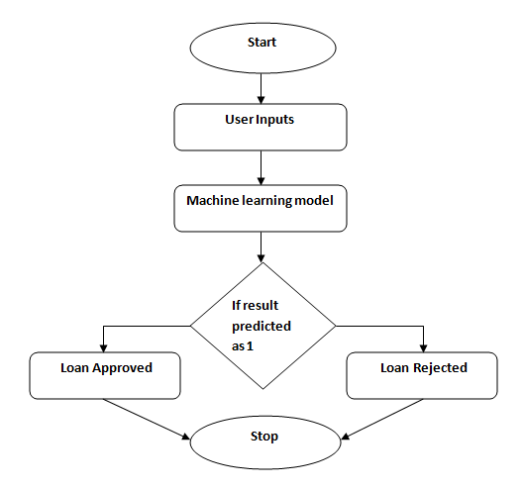

**Modules**

Data Pre-processing

Model Building

Training and Results

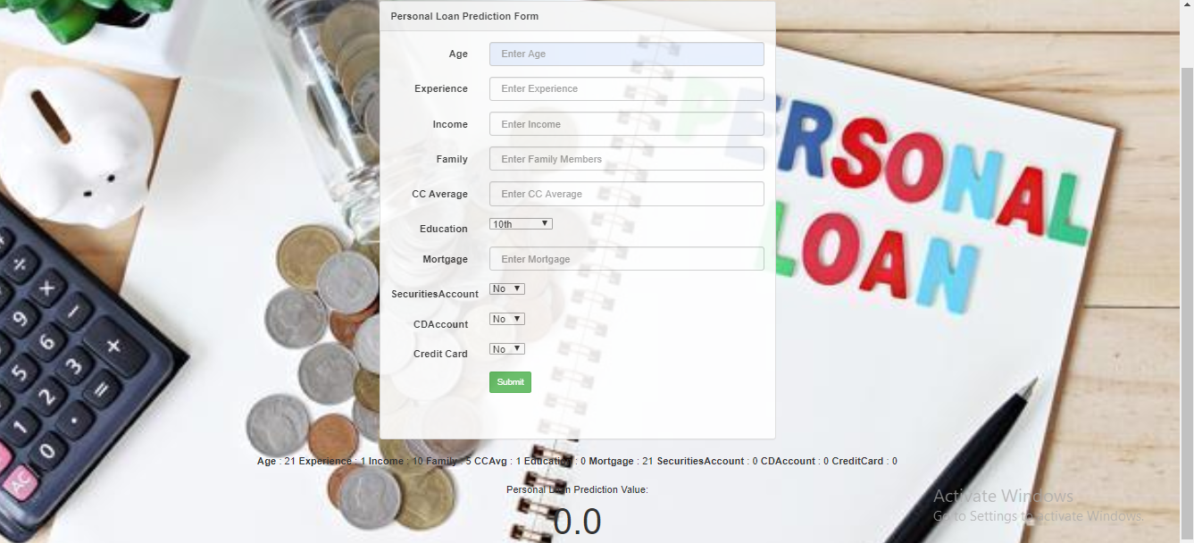

**Abstract**

The number of people applying for the loans got increased for various reasons in recent years. The bank employees are not able to analyze or predict whether the customer can payback the amount or not for the given interest rate. The aim of this project is to find the nature of the client applying for the personal loan. This project classifies the customers based on certain criteria. From a proper analysis of data set and constraints of the banking sector, three different algorithms have been used to train the model and the most accurate one has been used.

**Web 2.0 technologies made users to spend more time on the Internet to search for answers about various questions.**

**16WH1A1241 Meghana Kadali**

**16WH1A1201**

**Addala Tejaswini**





**TEAM**

**9**

**Tools and Technologies**

* **Jupyter Notebook**
* **Python Libraries**
* **HTML and BootStrap**
* **Flask**

**Conclusion**

The main purpose of the project is to classify and analyze the nature of the loan applicants. From a proper analysis of data set and constraints of the banking sector, three different algorithms have been used to train the model and the most accurate one has been used. This will be of a great use for the banks and also every individual. It will reduce the errors and will make the banks business more effective and will also simultaneously reduce our time.

**Guide**

**Ms. M. Swathi**

**Assistant Professor of IT**

**Swathi.m@bvrithyderabad.edu.in**

**Team**

**Personal Loan Predictor**

**BVRIT HYDERABAD**

**College of Engineering for Women**

**Department of Information Technology**

**Mini Project - Academic Year 2019-20**